This tutorial provides instructions on how to use SoapUI to access HPC DME APIs. Please refer to “HPC_User_Guide.pdf” to get details on “What is HPC DME and How to use it?”. Please refer to “HPC_Server_API.pdf” for API specification details.

**Accessing HPC DME REST API with SoapUI**

SoapUI supports extensive testing/accessing of RESTful web services and their resources, representations, etc.

**Prerequisites:**

1. Extract HPC_DME_SOAPUI_Training.zip. You should see following files in the folder “hpc_dme_soapui_tutorial”.

* hpc-training-soapui-project.xml
* dataRegistration-async.json
* dataRegistration-sync.json
* SRR062635.filt.fastq

1. If you do not have SoapUI installed, please go to following link to download and install it.

<https://www.soapui.org/downloads/soapui.html>

1. Valid NCI UserId and password to authenticate with HPC DME API
2. Contact HPC DME administrator to get access on training application

**Accessing REST API:**

Only valid authenticated and authorized users are allowed to access HPC DME APIs. To access HPC DME API, you will need to provide NCI UserId and Password through “Basic” authentication method. As showin the picture below, click on “Authentication and Security related settings” button. Select “Add New authorization” and select “Basic”. This step has to be done for every API request you make from SoapUI. Once you set it up for a request, you don’t have to recreate “Authentication and Security related settings” again.

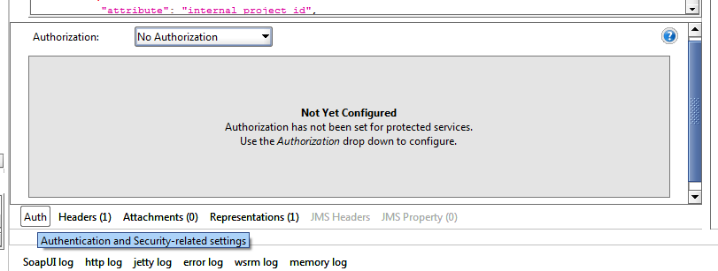

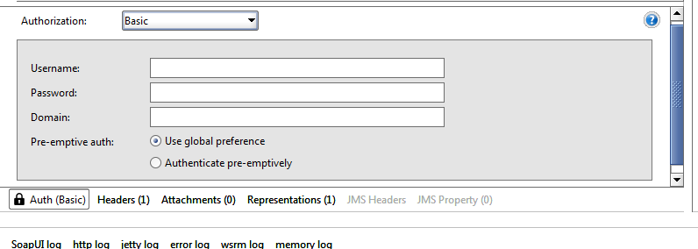

1. Import SoapUI Project

Once the installation is complete, open SoapUI tool and select “Import Project” from File menu. Select “hpc-training-soapui-project.xml”.

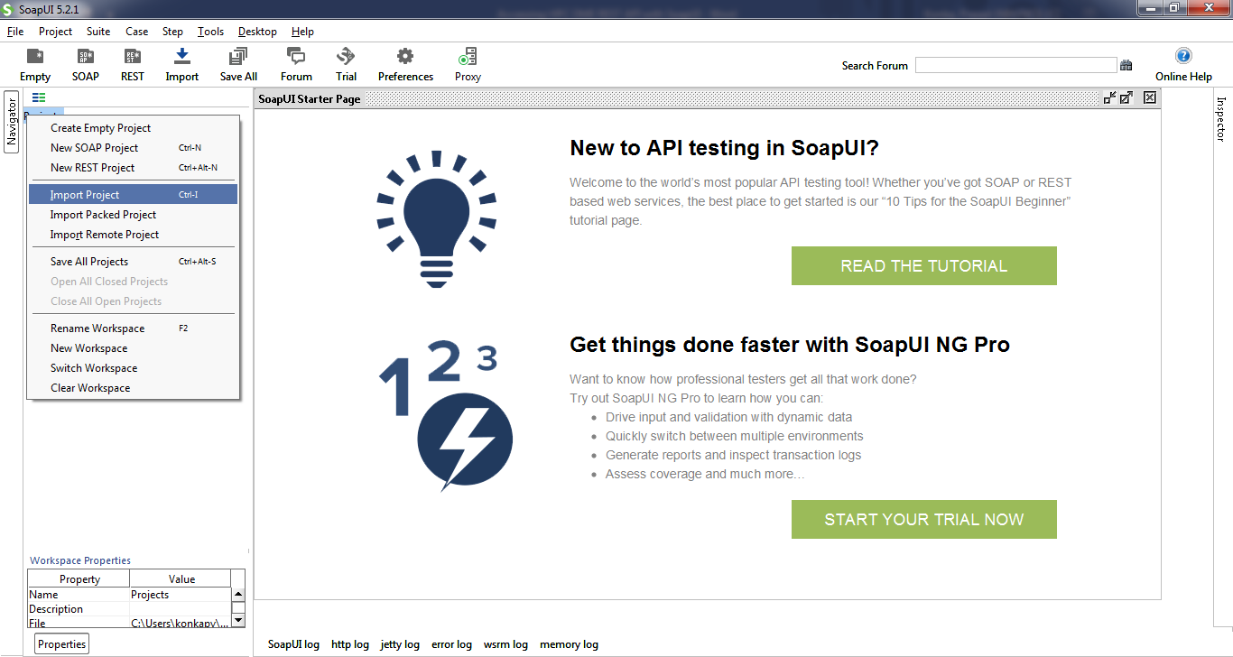

Once the project is imported, you will see the project in the navigator. This project is created with resources to access HPC DME REST interfaces. The training project is prepopulated with multiple endpoint to access. Please select any endpoint that you have access to.

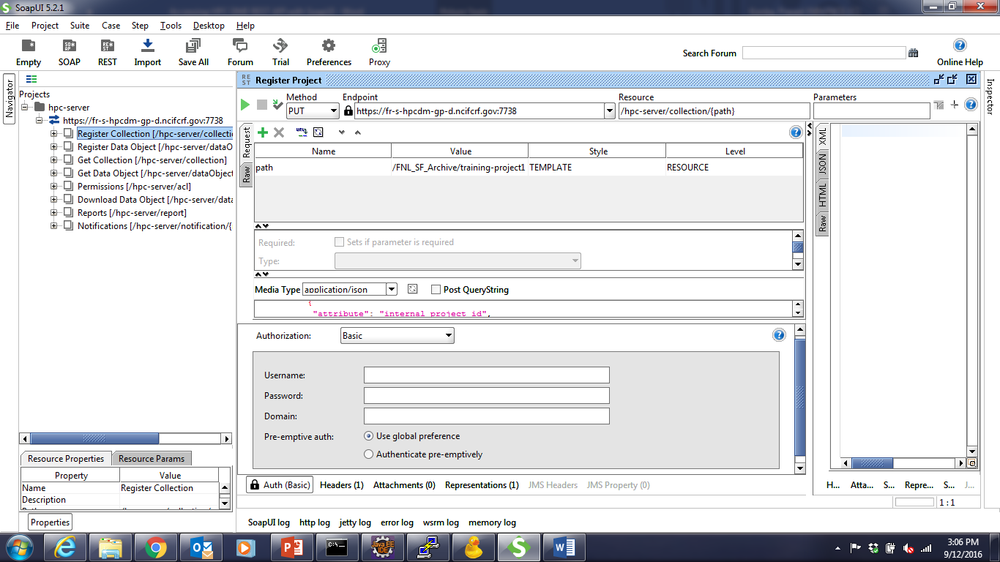

1. **Registering a Project:**

“Project” is one of the collection types setup on the training endpoint. Expand “Register Collection” node, “PUT” and double click on “Register Project”. Make sure select training endpoint from the endpoint drop down. In the request section, edit “Value” column to enter desired project path. Path is a logical unique identifier to refer to a collection. For example, “/FNL_SF_Training/konkapv/Project1”. Click on triangle icon to submit request. You shall see the response from “Raw” tab.

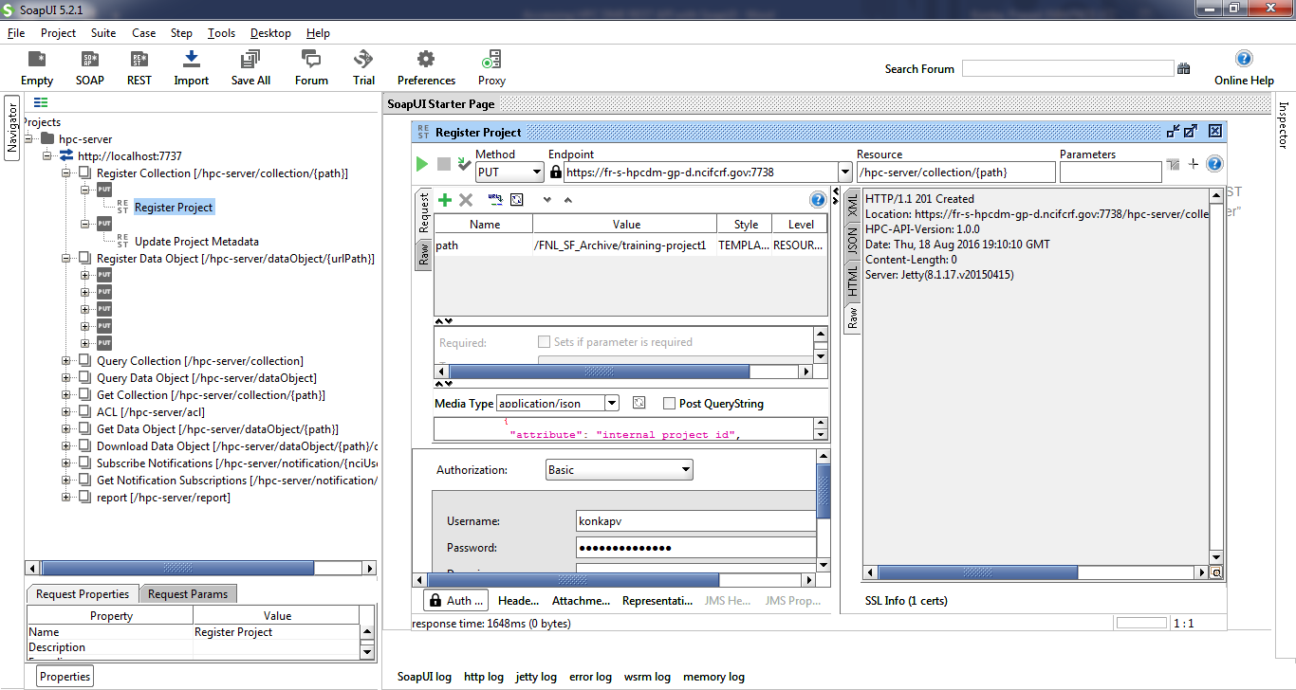

1. **Update a Project:**

An existing Collection (Project) metadata can be updated to add new metadata attributes or update existing metadata attribute value. Open “Update Project Metadata” resource and make sure request attribute value shows any existing project path. For example, “/FNL_SF_Training/konkapv/Project1”. You may edit metadata input information from media window. Click on triangle icon to submit request. You shall see the response from “Raw” tab.

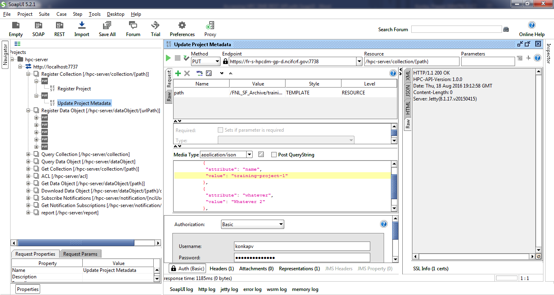

1. **Query Collection (Project) by path:**

Collections can be queried by their metadata or by its unique logical path. Double click on request path attribute value and enter a valid collection path. For example, “/FNL_SF_Training/konkapv/Project1”. Click on triangle icon to submit request. You shall see the response from “JSON” tab.

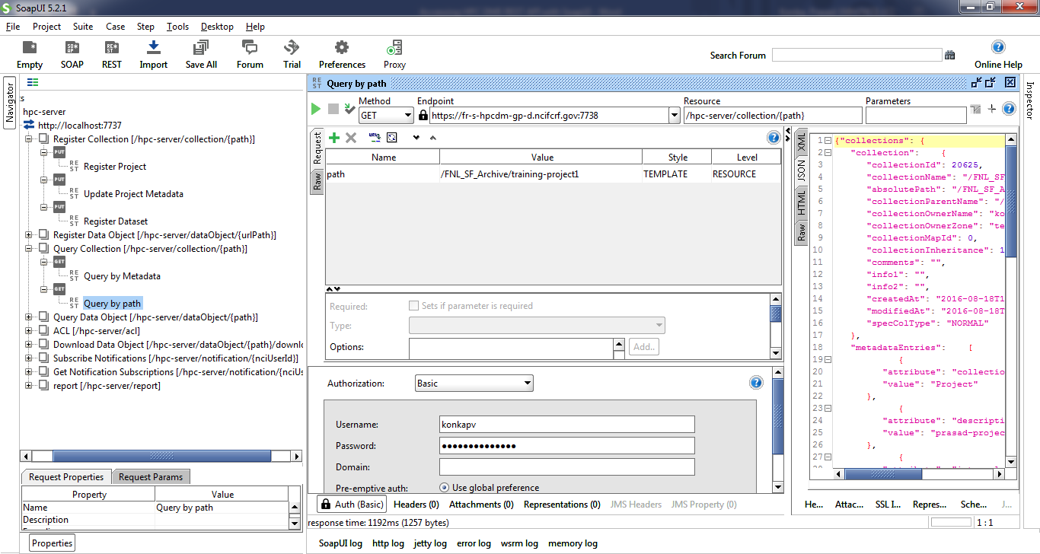

1. **Query Collection by metadata:**

Collections can be queried by their metadata. Due to the limitation of adding multiple values to a parameter, you could only search by one metadata attribute. Double click on metadataQuery request attribute value field and enter search criteria.

Format is

{"a":"<attribute name>","v":"<Value>","o":"<Operator>"}

Replace <text> with the actual values. Valid values for <Operator> are

EQUAL, NOT_EQUAL, LESS_THAN, GREATER_THAN, LIKE

Example:

{"a":"name","v":"%training%","o":"LIKE"}

Click on triangle icon to submit request. You shall see the response from “JSON” tab.

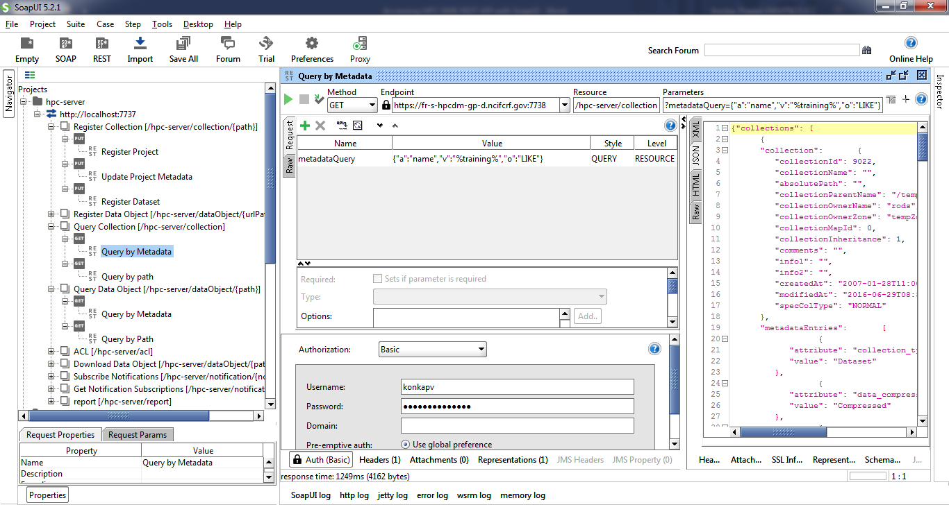

1. **Registering a Dataset:**

Dataset is another type of collection, similar to project, but it is a child of project. Double click on “Register Dataset”. Make sure to select training endpoint from the endpoint drop down. In the request section, edit “Value” column to enter desired dataset path. This path should be child of an existing project. For example, “/FNL_SF_Training/konkapv/Project1/Dataset1”. “Click on triangle icon to submit request. You shall see the response from “Raw” tab.

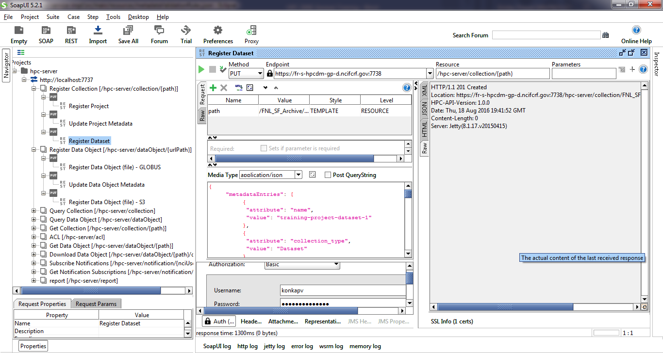

1. **Register Data object (Asynchronous)**

Prerequisite to register data object asynchronously is to have the data source location at a Globus endpoint with shared access to “ncif-hpcdm-svc” account. To create a shared access, login into [www.globus.org](http://www.globus.org) and select the endpoint where your data is located. Select the folder, and click on the icon on top right corner of the section. Click on “Share”.

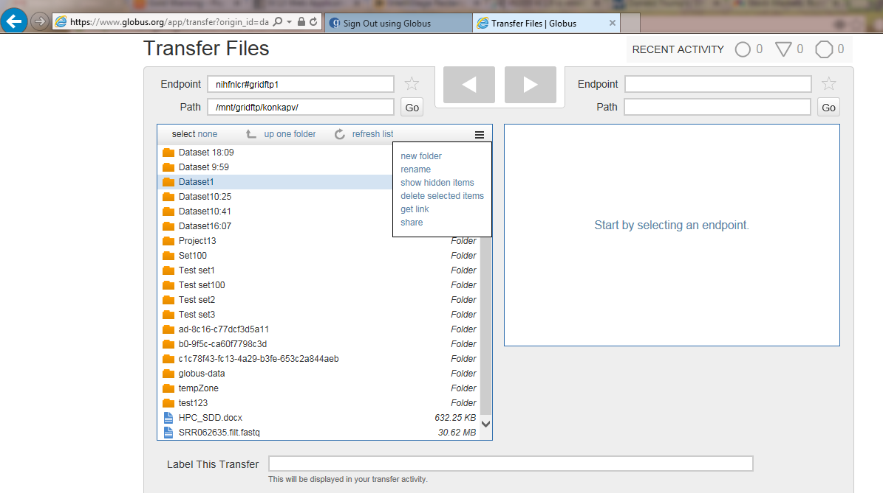

Enter “Share Display Name” and click on “Create” button.

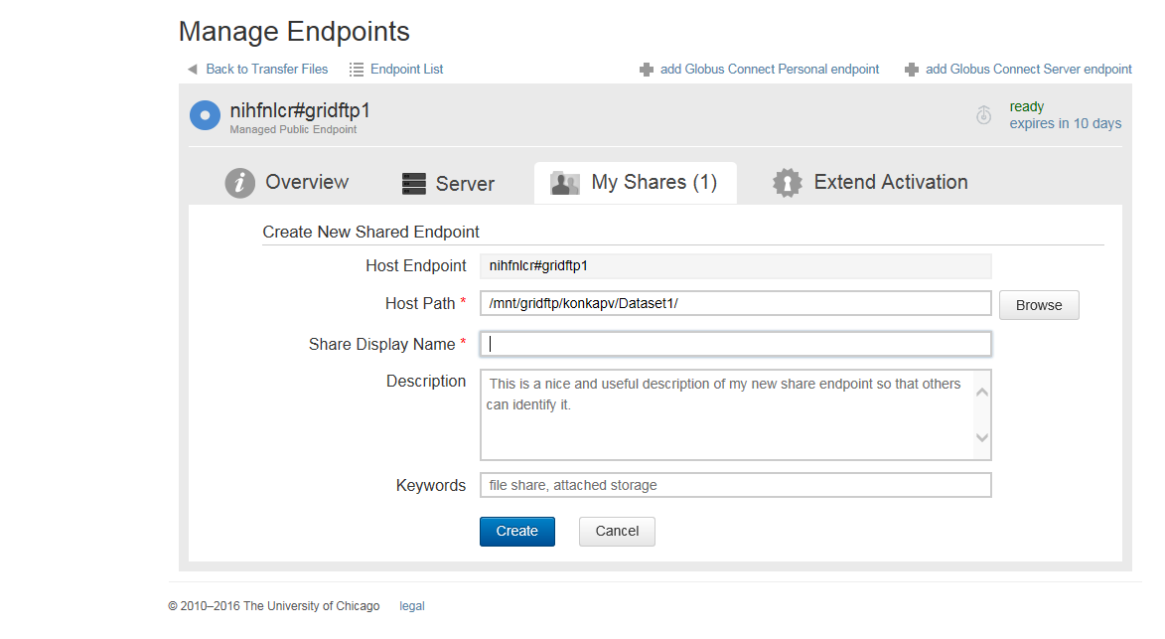

On data sharing page, select “User” radio button and click on “Search” button.

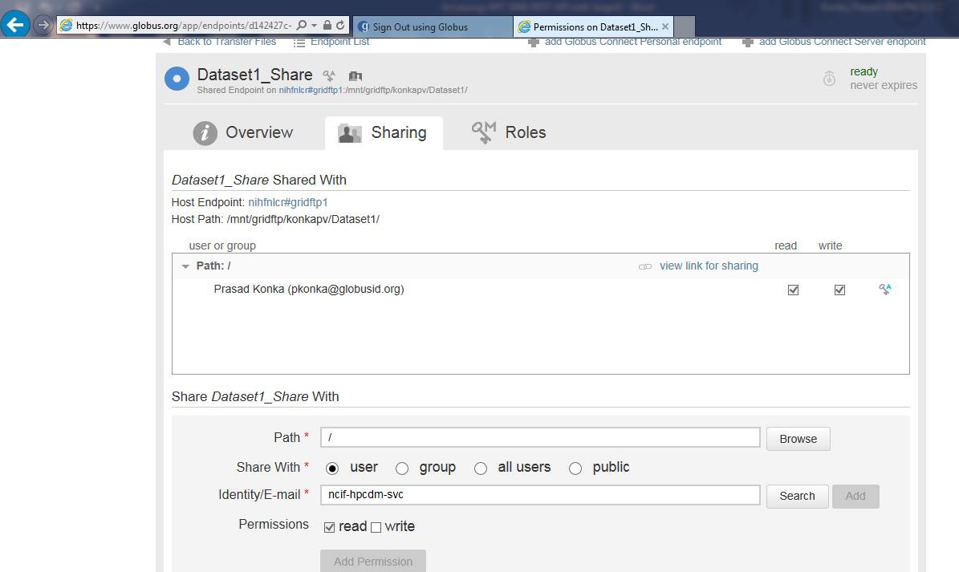

On “Search for a User” dialog, enter “ncif-hpcdm” and click on search icon. Select “Zaki Zaki” service user account.

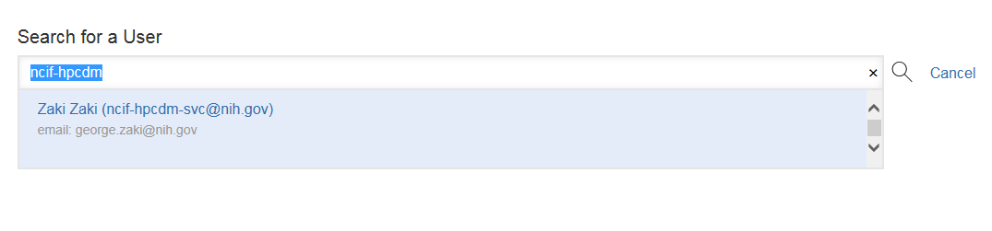

Uncheck “Send Email” and make sure “read” permission is selected. Click on “Add permission” button.

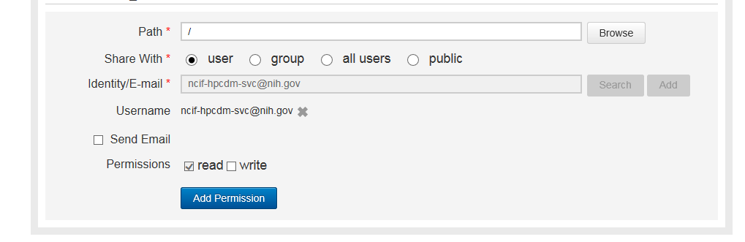

Data file registration is done via HTTP multipart request to HPC REST interface. Tutorial package has sample metadata file (dataRegistration-async.json) to register. Edit “dataRegistration-asyn.json” package to set source fileContainerId and source fileId. “fileContainerId” is the Globus UUID and “fileId” is the full path of the file exist on Globus.

Click on “attachments” tab and click on + sign shown below to add an attachment.

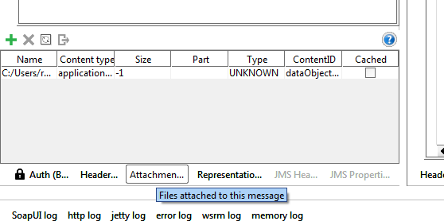

Select “dataRegistration-asyn.json” you edited. Once it is attached, double click on “Content type” and enter “application/json” as the value. Double click on “ContentId” and enter “dataObjectRegistration” as the value.

Double click request value to enter unique object path value. For example, “/FNL_SF_Training/konkapv/Project1/Dataset1/Object1”.

Click on triangle icon to submit request. You shall see the response from “Raw” tab.

1. **Register Data object (Synchronous)**

Data file registration is done synchronously via HTTP multipart request to HPC REST interface. Tutorial package has sample metadata file (dataRegistration-sync.json) to register. Edit “dataRegistration-syn.json” to update any metadata. Following attachments are expected:

1. Attach metadata to the request (multipart)
   1. ContentType: application/json
   2. ContentID: dataObjectRegistration
2. Attach data object to the request (multipart)
   1. ContentType: application/octet-stream
   2. ContentID: dataObject

Click “Attachments” tab and click on the + sign shown below to add attachments mentioned above.

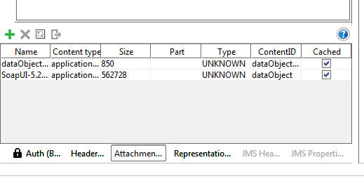

Select “dataRegistration-sync.json” you edited. Double click on “Content type” and enter “application/json” as the value. Double click on “ContentId” and enter “dataObjectRegistration” as the value.

Click on the + sign shown below to add attachments mentioned above. Select data object file you want to register. Double click on “ContentId” and enter “dataObject” as the value.

Double click request value to enter unique object path value.

Click on triangle icon to submit request. You shall see the response from “Raw” tab.

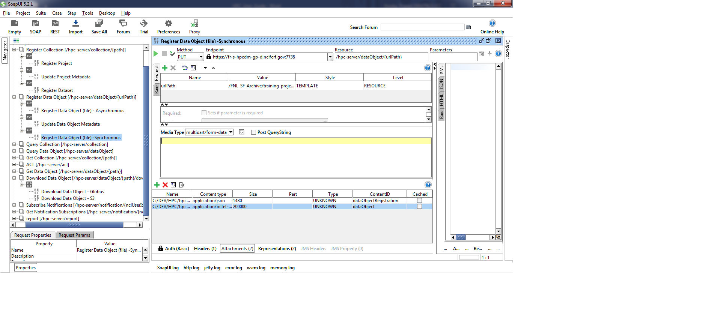

1. **Get Data object by path:**

Data objects can be queried by their metadata or by its unique logical path. Double click on request path attribute value and enter a valid data object path. Click on triangle icon to submit request. You shall see the response from “JSON” tab.

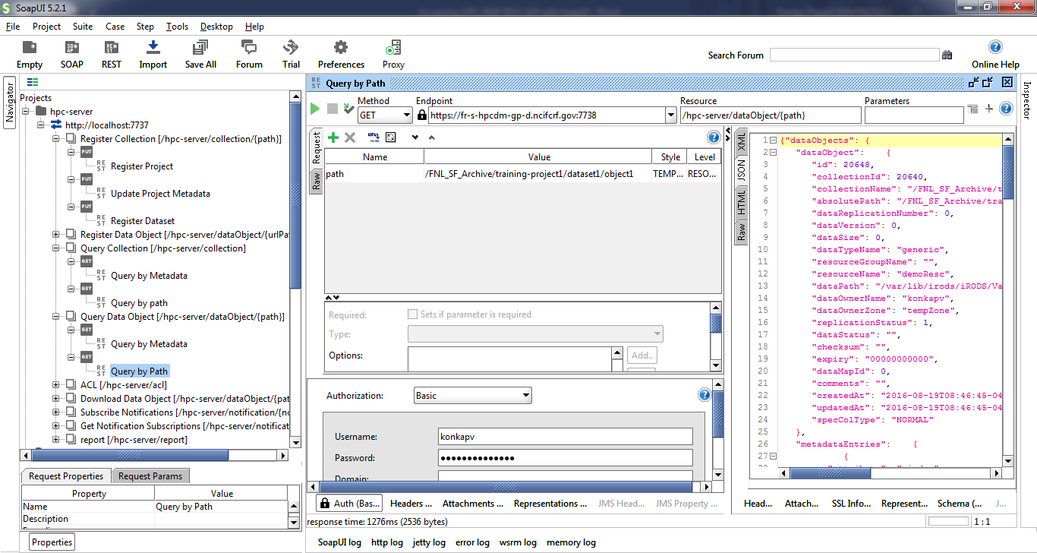

1. **Get Data object by metadata:**

Data objects can be queried by their metadata. Due to the limitation of adding multiple values to a parameter, you could only search by one metadata attribute. Double click on metadataQuery request attribute value field and enter search criteria.

Format is

{"a":"<attribute name>","v":"<Value>","o":"<Operator>"}

Replace <text> with the actual values. Valid values for <Operator> are

EQUAL, NOT_EQUAL, LESS_THAN, GREATER_THAN, LIKE

Example:

{"a":"name","v":"%object%","o":"LIKE"}

Click on triangle icon to submit request. You shall see the response from “JSON” tab.

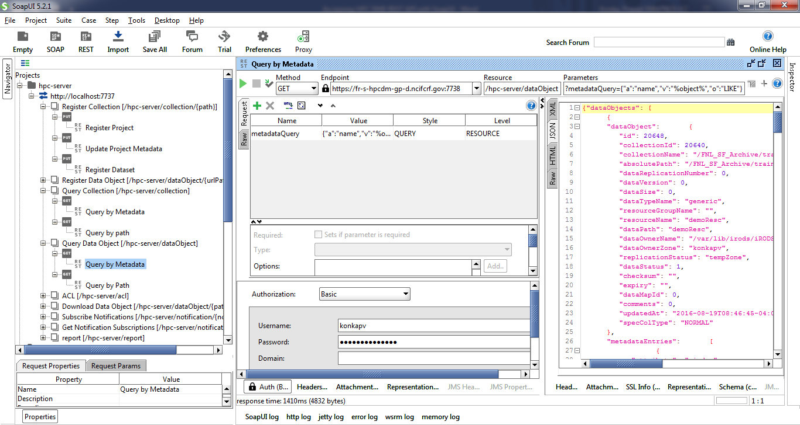

1. **Set Permissions:**

You can set permissions on the collections or data objects so that any other authenticated user can access your data. Supported permissions are OWN, READ, WRITE and NONE.

These permissions can be associated with a user or a group. These permissions are set by entity PATH. This entity can be a collection or a datafile.

Edit request media string to enter value entities and permissions.

Click on triangle icon to submit request. You shall see the response from “JSON” tab.

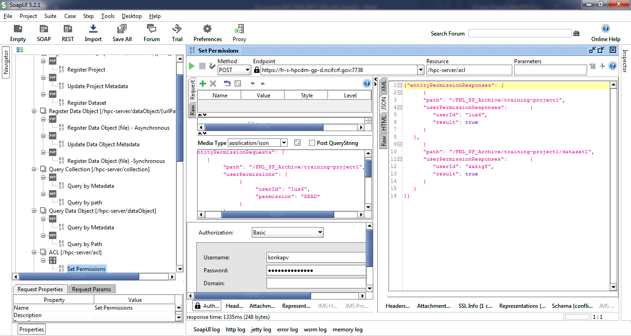

1. **Download data object - Asynchronously:**

You can download a data object that you have access to into your Globus endpoint location asynchronously. The destination Globus endpoint should be shared with “ncif-hpcdm-svc” account to write. Please see section 7 on how to create a share endpoint. For download, you need to give “write” access on shared location to service account. Double click on request path attribute value and enter valid object path.

Edit destination values as needed.

Click on triangle icon to submit request. You shall see the response from “JSON” tab.

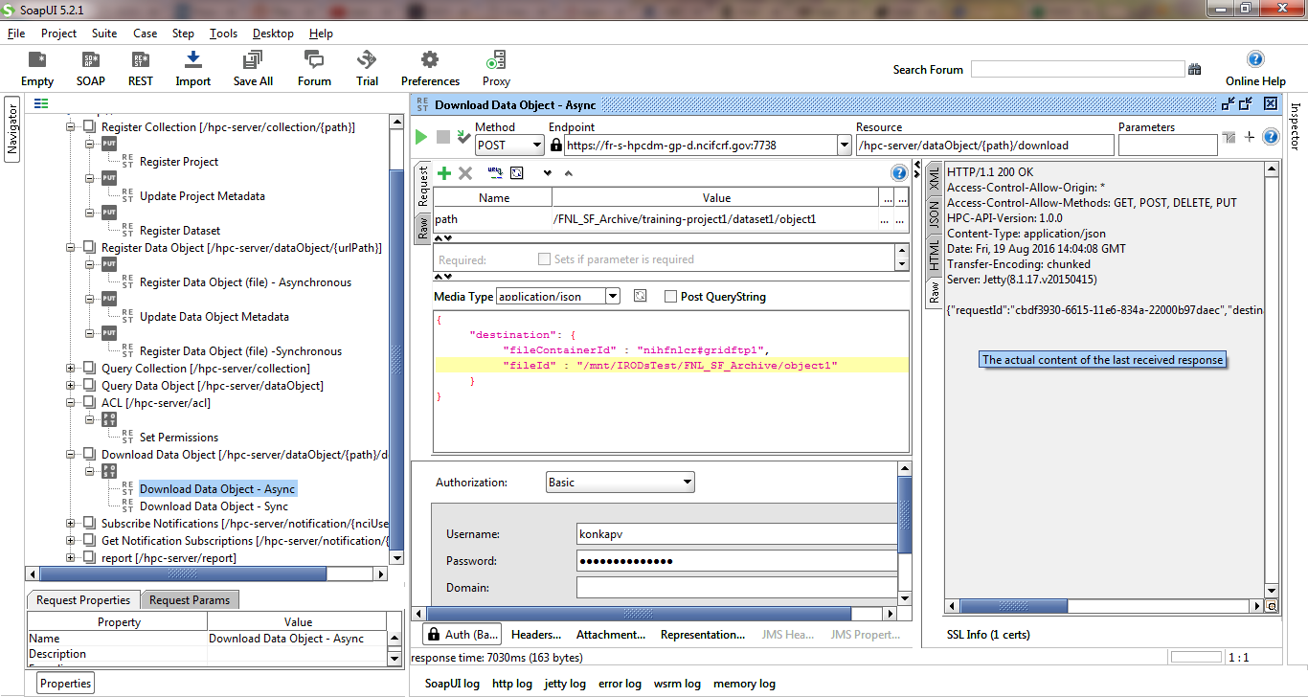

1. **Download data object - Synchronously:**

You can download from the archive to your local file system synchronously. Double click on request path attribute value and enter valid object path. Click on triangle icon to submit request. You shall see the response from “JSON” tab.

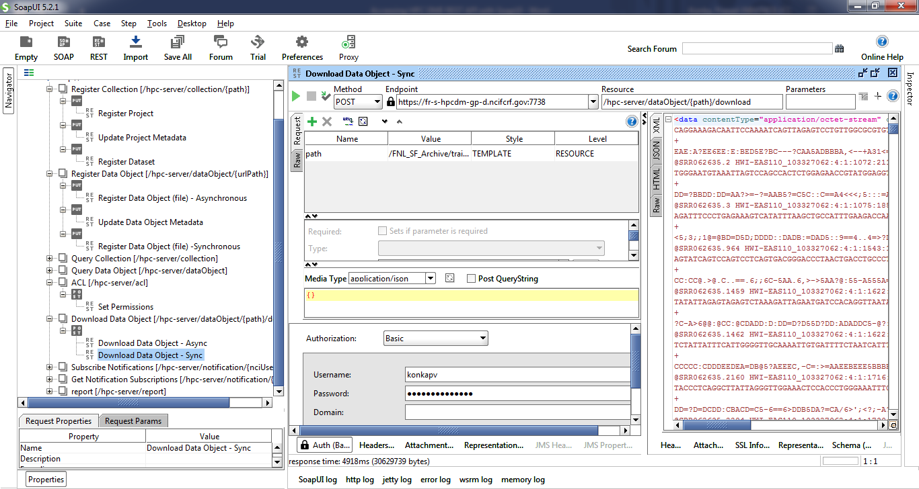

1. **Subscribe to notification:**

You may subscribe to get notification emails to the events generated during data upload and download requests. This subscription is to get notification on the requests you initiate. You can also unsubscribe from some of the notifications you are already subscribed to.

Following are the valid event notifications:

DATA_TRANSFER_UPLOAD_IN_TEMPORARY_ARCHIVE:

DATA_TRANSFER_UPLOAD_ARCHIVED:

DATA_TRANSFER_UPLOAD_FAILED:

DATA_TRANSFER_DOWNLOAD_COMPLETED:

DATA_TRANSFER_DOWNLOAD_FAILED:

Edit request media content as needed. Click on triangle icon to submit request. You shall see the response from “RAW” tab.

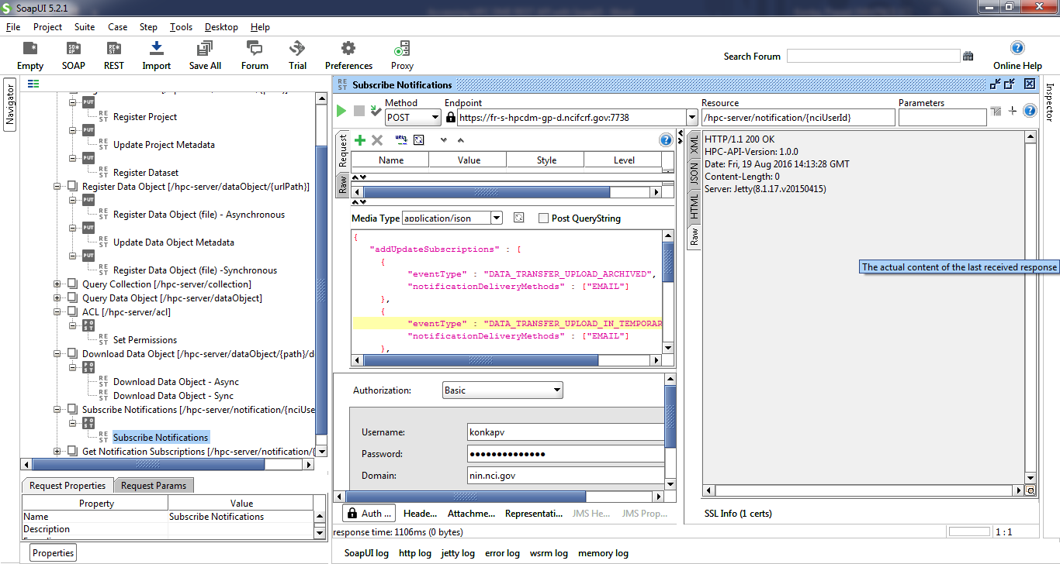

1. **Generating reports:**

Authorized users can generate following summarized reports

Summary report till date

Summary report by date

Summary report by DOC

Summary report by DOC and data range

Summary report by User

Summary report by User and data range

Valid report types are:

USAGE_SUMMARY

USAGE_SUMMARY_BY_DATE_RANGE

USAGE_SUMMARY_BY_DOC

USAGE_SUMMARY_BY_DOC_BY_DATE_RANGE

USAGE_SUMMARY_BY_USER

USAGE_SUMMARY_BY_USER_BY_DATE_RANGE

Edit request media content to enter valid request JSON request. Click on triangle icon to submit request. You shall see the response from “JSON” tab.

